Survey: Water Supply for Penrose & Wingello
www.wsc.nsw.gov.au

Council is seeking feedback about the possible introduction of a water supply service to the Wingello and Penrose areas.

Our staff have identified a number of villages which may wish to connect to a reliable water service in the next 10 to 20 years and are commencing the very early and tentative stages of community consultation to determine whether Council should commence design work or just keep it listed as a possibility in the distant future.

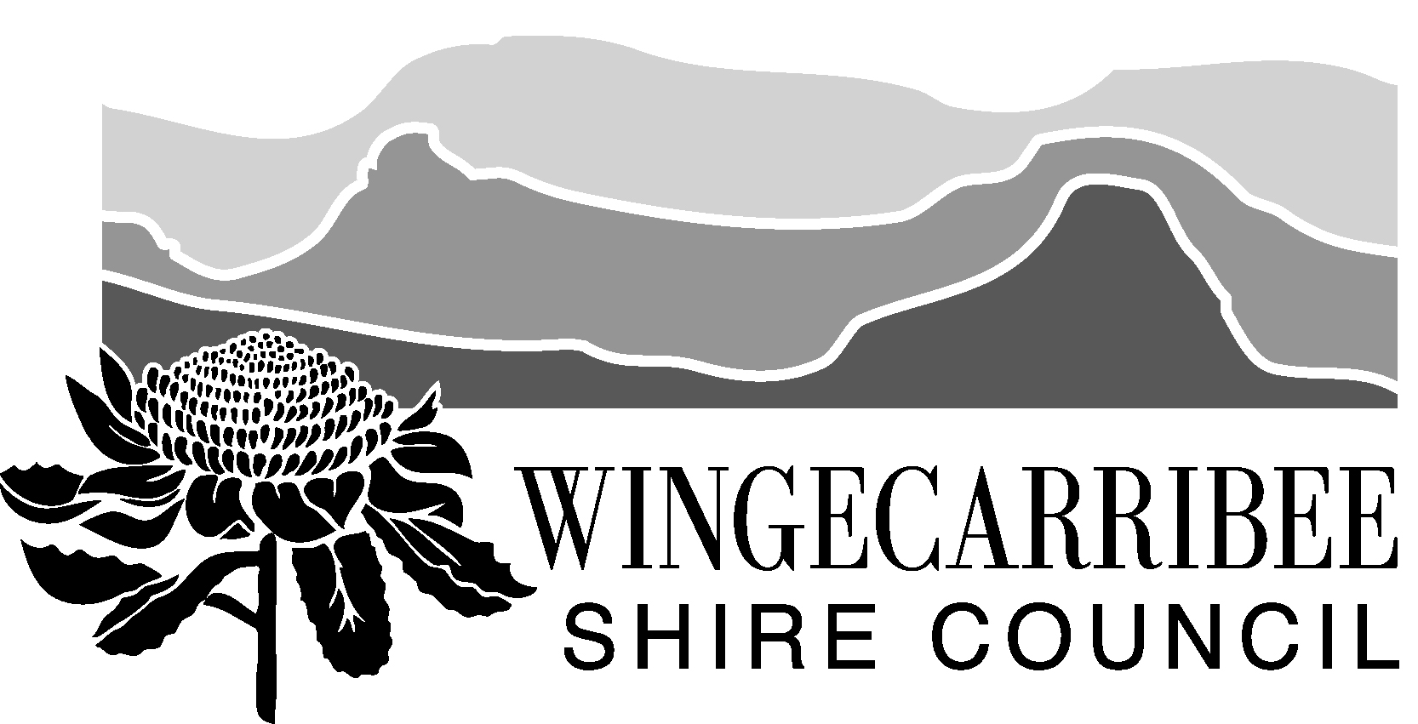
We hope that you will find a few spare minutes to complete the survey online at www.yoursaywingecarribee.com.au or return this copy by Monday 31 March 2014.

RECOMMENDED READING: An information kit has been prepared which explains fees and charges involved, details the proposed service and answers frequently asked questions. Please read this before completing the survey. NOTE: Each survey has been coded to prevent multiple completions.

Complete this survey online , participate in discussion forums or find out more
about the proposal at www.yoursaywingecarribee.com.au

1. In which village or locality do you live or own property?
Penrose Wingello
Other: _______________________________________

2. Of the three options outlined in the information pack, which suits you most? [Tick one only]
Option 1 – Water service provided, no wastewater
Option 2 – Water service provided, plans for wastewater
Option 3 – No water or wastewater services provided

Why have you chosen this option? ____________________
_________________________________________________

3. If the service became available, how long after completion would you connect to the service? [Tick one only]
Within 6 months
6 months – 1 year
Later than 1 year
I wouldn’t ever connect (go to Question 6)

4 For what purpose(s) would you connect to the potable drinking water service if it became available?
Domestic [Tick as many as apply]
Agricultural
Commercial
Industrial

5. If the service became available, how much water do you foresee your property using per year? [Tick one only]
Less than 100kL
100kL – 225kL
225kL or more
I don’t know

6. How do you currently source water?
Rainwater tank [Tick as many as apply]
Bore water
Bulk buying
Other: ________________________________________

Comments: ______________________________________
7. How would you rate the quality of the water you currently use? [Tick one only]
Excellent
Average
Poor

8. How confident are you that your current water supply could withstand a fire or extreme drought emergency?
Confident [Tick one only]
Doubtful
I don’t know

9. Do you think you’d have financial difficulty paying COUNCIL to connect to the water mains in 2021 if the proposal went ahead?
Yes No Unsure [Tick one only]

Comments: _________________________________________

10. Do you think you’d have financial difficulty paying a PLUMBER to connect to the proposed water service in 2021 if the proposal went ahead?
Yes No Unsure [Tick one only]

Comments: _________________________________________

11. Use this space to outline your concerns about or support for the proposed project:
___________________________________________________
___________________________________________________
___________________________________________________
___________________________________________________

Property Number: XXXXX

ABOUT YOU
12. How long have you lived in and/or owned property in this area?
Less than 5 years
6 – 15 years
Over 15 years

13. Which option best describes you? [Tick one only]
I own and live in a house in the Penrose/Wingello area
I rent and live in a house in the Penrose/Wingello area
I own a holiday home/weekender in Penrose/Wingello
I own property in the area
Other: _______________________________________

14 Which category below includes your age?
24 years or under 45-64 years
25-44 years 65 years and over

Fold here 
WATER SERVICE SURVEY (Penrose and Wingello)

15 Your name: ____________________________________

16 Your street address: _____________________________
___________________________________________________

17 Postal address (if different to street address):

___________________________________________________

18 What is your email address?
___________________________________________________

19 Could Wingecarribee Shire Council use your contact details to keep you informed about this project or seek feedback on other proposals?
No Yes (please provide contact details above)

THANK YOU FOR ASSISTING US. Wingecarribee Shire Council appreciates the time you have spent answering our questions. Our research is carried out in compliance with the Privacy Act and the information you have provided will only be used for research purposes. Your anonymous responses will assist Council to determine whether to construct a water supply service for the Wingello and Penrose areas.

Please complete and return this survey by Monday 31 March 2014. Please fold the page where indicated to maintain privacy, seal with a piece of tape (not so much that we can’t open it) and mail it back.

FOR FURTHER INFORMATION please contact the Water and Sewer Asset team on 4868 0888, email wscmail@wsc.nsw.gov.au or submit a question online at www.yoursaywingecarribee.com.au

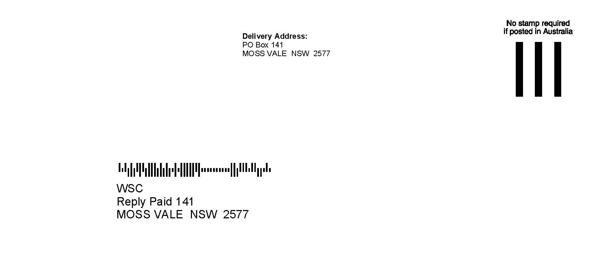
Fold here 
WATER SERVICE SURVEY (Penrose and Wingello)

